***AEC LAB REPORT – 1***

**RC Circuits and Diode Characterization**

***Name****: Khyathi Sri Basireddy*

***Roll No****: 2023102065*

***Table No****: 9*

**1. Know your Equipment**

(b)

**(i) Oscilloscope and Function Generator**

R, C specifications of oscilloscope channel: 1Mohm and 16pF respectively

R, C specifications of probe are 10X: 10Mohm and 15pF

1X: 1Mohm and 100pF

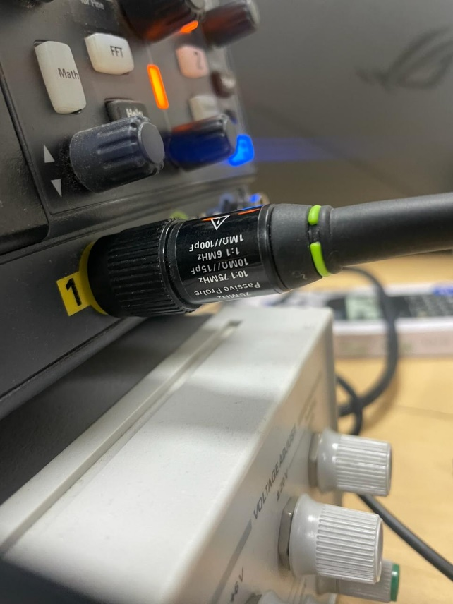

**(ii) Parameter of Demo Signal**

Shape: Square Wave

Amplitude: 5 Vpp

Frequency: 1.0002 kHz

Probe Ratio: 1X

OSC Factor: 1:1

Offset: 0

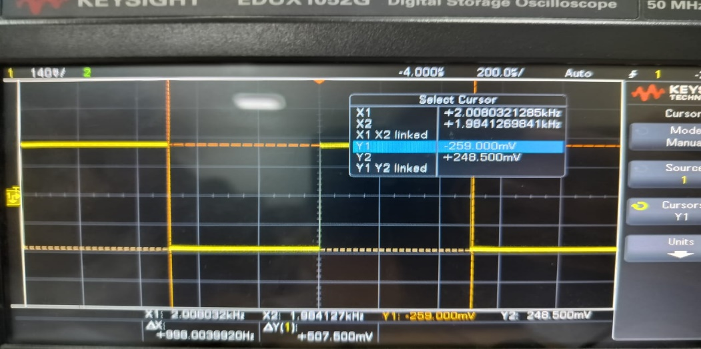

**(iii) VOSC = (OSCfactor / Probefactor) × Vin**

|  |  |  |  |  |  |  |
| --- | --- | --- | --- | --- | --- | --- |
| **Type of**  **Signal** | **Amplitude**  **Vin (Vpp)** | **Frequency** | **Probe**  **Factor** | **OSC Factor** | **Vosc**  **measured** | **Vosc** |
| Square wave | 5 Vpp | 1 kHz | X1 | 1:1 | 4.99V | 5V |
| Square  wave | 5 Vpp | 1 kHz | X10 | 1:1 | 500mV | 0.5V |
| Square wave | 5 Vpp | 1 kHz | X10 | 10:1 | 5V | 5V |
| Square  wave | 5 Vpp | 1 kHz | X1 | 10:1 | 49.5V | 50V |

The Vosc calculated in every case is almost equal to the Vosc measured in the DSO.

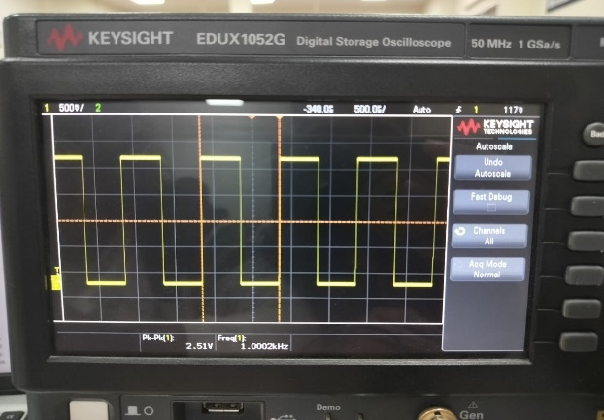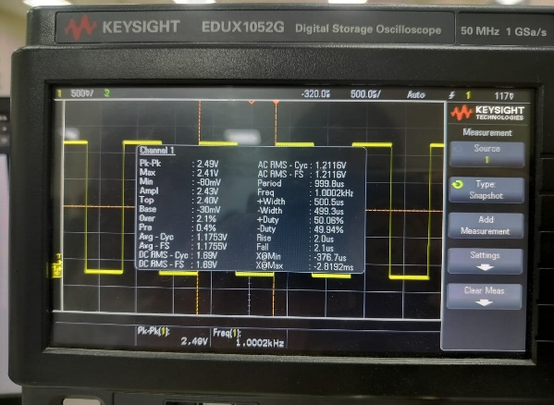

**(iv) Spectrum with FFT:**

Space – sine wave

F = 10kHz

Span = 100kHz

Center = 50Hz

Vin = 5 Vpp

Probe = x1

OSC Factor = 1:1

FFT Offset = -40dbV

For FFT,

1st harmonic = 10kHz

2nd harmonic = 14kHz

3rd harmonic = 19.8kHz

4th harmonic = 70.3kHz

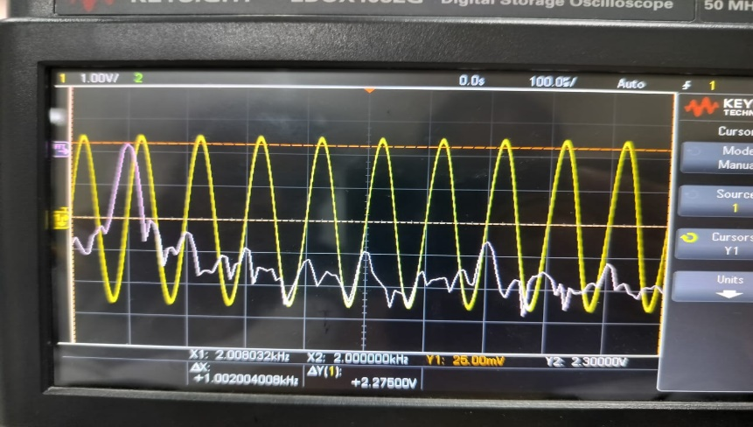

**(v) Frequency Spectrum with and without filter:**

Shape – square wave

Fundamental frequency – 10kHz

Input Amplitude = 5 Vpp

FFT - Span = 100kHz

Centre = 50Hz

Scale = 20dB

Offset = 0

FFT Resolution = 1.53kHz

**RC Low-pass Filter:**

Choose a reasonable R and C combo. Preferably more than the fundamental frequency.

C = 44nF

R = 200 ohm

Cutoff frequency = 1/2piRC

= 16.9 kHz

From the observations in table below,

We can say that the RC circuit filters out all the signal whose harmonic frequency is more than the cutoff frequency of the low pass filter.

This can be evidently seen by the decrease in the signal strength.

|  |  |  |  |  |  |
| --- | --- | --- | --- | --- | --- |
|  | 1st harmonic | 2nd harmonic | 3rd harmonic | 4th harmonic | 5th harmonic |
| Without Filter | f: 10kHz  s: 6.83 dBV | f: 30.7kHz  s: -3.28 dBV | f: 50.1kHz  s: -7.69 dBV | f: 70.2kHz  s: -10.2 dBV | f: 90kHz  s: -12.6 dBV |
| With Filter | f: 10kHz  s: 6.7 dBV | f: 30.7kHz  s: -4.14 dBV | f: 50.1kHz  s: -9.57 dBV | f: 70.2kHz  s: -13.4 dBV | f: 90kHz  s: -17.1 dBV |

Where s = strength, f = frequency

Here we can see a noticeable change in signal strength from the second harmonic and so on.

Since the frequency of harmonics from 2nd is greater than the cut off frequency.

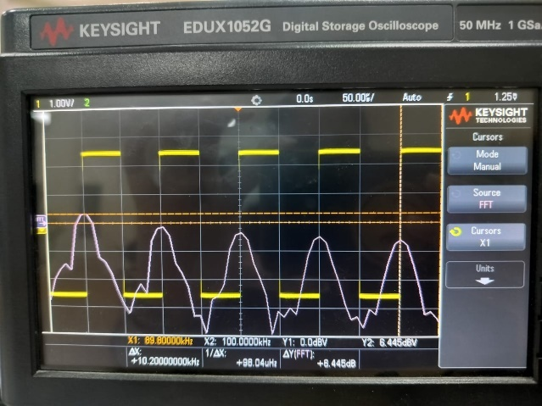

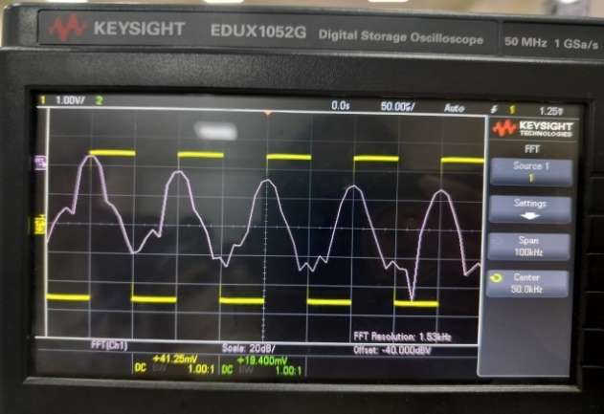

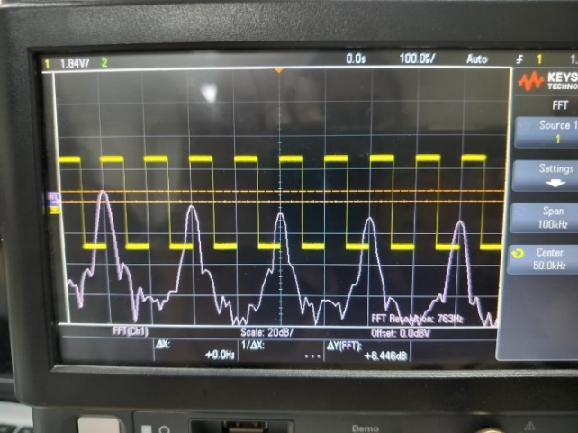

**2. Estimate the effective probe-capacitance**

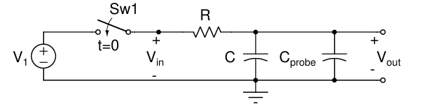

Time constant (theoretical)=RC circuit

Time constant(observed)=R (C circuit +C probe)

R = 1M ohm

C = 10 pF

Frequency, f = 1/2piRC

= 16k ohm

Time Constant, T = RC = 10 us

|  |  |  |  |  |
| --- | --- | --- | --- | --- |
| C load | Probe factor | Calculated Time Constant | Measured Time Constant | C probe |
| 10pf | X1 | 10us | 108us | 98pF |
| 27pf | X1 | 10us | 131us | 104pF |
| 100pf | X1 | 10us | 201us | 101pF |
| 10pf | X10 | 10us | 22us | 12pF |
| 27pf | X10 | 10us | 38us | 11pF |
| 100pf | X10 | 10us | 118us | 18pF |

The table shows that, in every case, the measured time constants are slightly greater than the estimated time constants. This suggests that the circuit contains extra capacitance because of the breadboard, cables, and probe. Greater levels of C load and probe factors result in greater estimated effective probe capacitances (C probe). This is due to the fact that a bigger C load requires charging and discharging a larger capacitance, which results in a longer time constant and a larger effective probe capacitance.

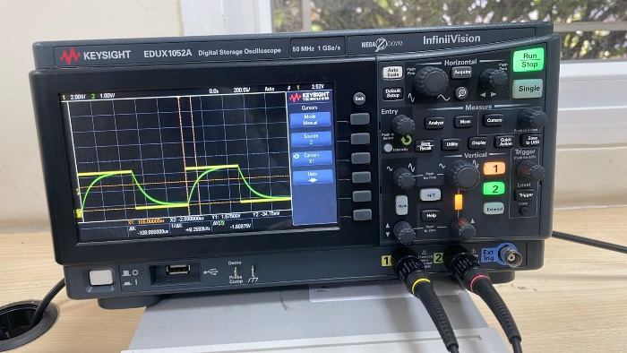

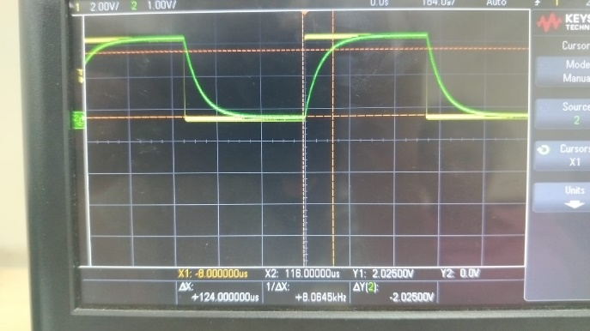

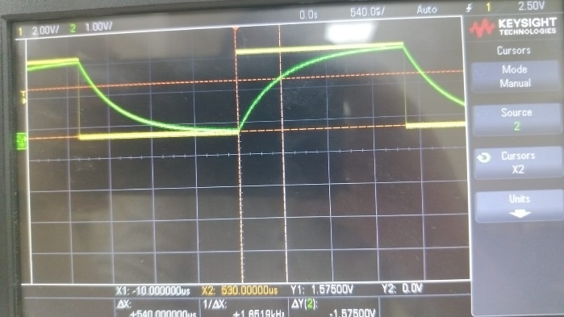

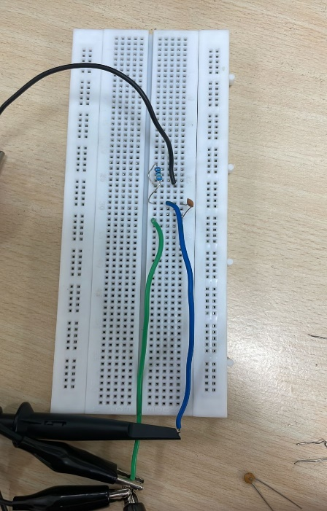

**3. Two capacitor experiment**

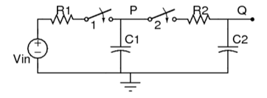

1) Apply a DC supply voltage of 1V with the help of the function generator.

2)Firstly, close the switch 1(push button is kept pressed) and switch 2 is opened. This allows the capacitor C1 to charge to the supply voltage(1V).

3)Now when C1 is completely charged, open switch 1 and close switch 2, then observe the voltage across nodes P and Q using probes in the oscilloscope.

4)Now change the resistance value to 10k ohm and do the same process as above.

Here we have R1 = R2 = 100k ohm

C1 = C2 = 1uF

|  |  |  |  |  |
| --- | --- | --- | --- | --- |
| **Resistance** | **Capacitance** | **Vp (initial)** | **Vp (final)** | **Time taken to reach steady state** |
| 100k ohm | 1uF | 0V | 1V | 490ms |

|  |  |  |  |  |  |  |
| --- | --- | --- | --- | --- | --- | --- |
| **Resistance** | **Capacitance** | **Vp (initial)** | **Vp (final)** | **Vq(initial)** | **Vq(final)** | **Time taken to reach steady state** |
| 100k ohm | 1uF | 0.98V | 0.49V | 0V | 0.48V | 265.6ms |
| 10k ohm | 1uF | 0.9V | 0.42V | 0V | 0.4V | 271ms |

